*A PROJECT REPORT ON*

**“BAKERY MANAGEMENT”**

*Submitted*

*In partial fulfillment*

*For the award of the Degree of*

Bachelor of Computer Application



2020-2021

SUBMITTED TO: GUIDEDED BY: SUBMITTED BY:

Ms. Simran Sharma Ms. Simran Sharma Riya Vaishnav

Department of BCA

St. Paul’s College of Science & Management, Kivarli March 2021

# DECLARATION

I Riya Vaishnav Student of Final year BCA St. Paul’s College of Science & Management, Kivarli do hereby declare that the Project entitled “Bakery Management” is the original work carried out by us under the supervision of Prof Simran Sharma towards partial fulfillment of BCA Degree.

Date: 25/03/2021 **Riya Vaishnav**

## ST. PAUL’S COLLEGE OF SCIENCE & MANAGEMENT SESSION 2020-21

**CERTIFICATE**

This is to certify that the work which is being presented in the BCA project entitled “BAKERY MANAGEMENT” has been submitted to the St. Paul’s College of Science & Management, Kivarli fulfilment of the requirement for the award of the degree of Bachelor of Computer Application.

Ms. Simran Sharma Date: 26/03/2021

**HOD PRINCIPAL**

**ACKNOWLEDGEMENT**

The satisfaction that accomplished that the successful competition of any task would be incomplete without the mention of people whose careless cooperation made it possible, whose constant guidance encouragement crown all efforts with success.

I am also grateful to my respected mentor, Ms. Simran Sharma for helping me with this project report finalization process showing confidence in me. Last but not the least I wish to avail myself to this opportunity, express a sense of gratitude and love to my friends and my beloved parents for their manual support, strength and help.

Thank you.

Riya Vaishnav

**ABSTRACT**

An online bakery shop that allows users to check for various bakery products available at the online store and purchase online. The project consists of list of bakery products displayed in various categories. The user may browse through these items as per categories. If the user likes a product he may add it to his shopping cart. Once user wishes to checkout he must register on the site first. He can then login using same id password next time. Now he may pay through a credit card or cash on delivery.

|  |  |  |
| --- | --- | --- |
| **CONTENTS** |  | |
| **T ITLE** | **P AGE NO.** | |
| **DECLARATION** |  | **I** |
| **CERTIFICATE** |  | **II** |
| **ACKNOWLEDGEMENT** |  | **III** |
| **ABSTRACT** |  | **IV** |
| **LIST OF CONTENTS** |  | **V** |
| **LIST OF FIGURES** |  | **VI** |
| **1. INTRODUCTION** |  | **1** |
| 1.1. Introduction of Sublime text |  | 2 |
| 1.2. Introduction to HTML |  | 3 |
| 1.3. Introduction to CSS |  | 4 |
| 1.4.Introduction to JavaScript 1.5.  **2. SYSTEM ANALYSIS** |  | 5  **6** |
| 2.1. Product Description |  | 6 |
| 2.2. Product Statement |  | 6 |
| 2.3.System Objectives |  | 6 |
| 2.4.Software tool used |  | 6 |
| **3. FEASIBILITY STUDY** |  | **7** |
| 3.1. Technical Feasibility |  | 7 |
| 3.2. Economic Feasibility |  | 7 |
| 3.3. Operational Feasibility |  | 7 |
| **4. SYSTEM DESIGN** |  | **8-10** |
| **5. DATABASE** |  | **11-12** |
| **FUTURE SCOPE** |  | **13** |
| **CONCLUSION** |  | **14** |
| **BIBLIOGRPHY** |  | **15** |

## LIST OF FIGURES

|  |  |  |
| --- | --- | --- |
| **Figure No.** | **Figure Name** | **Page No.** |
| Figure 1.1.1. | Sublime Text | 2 |
| Figure 4.1. | Home page of Bakery Management | 8 |
| Figure 4.2. | Menu page of Bakery Management | 8 |
| Figure 4.3. | About us page | 9 |
| Figure 4.4. | Contact us page | 9 |
| Figure 4.5. | Home page with Dark mode | 10 |
| Figure 4.6. | Services and address | 10 |

# 1. INTRODUCTION

A bakery is an establishment that produces and sells flour-based food baked in an oven such as bread, cookies, pastries, and pies. Some retail bakeries are also categorized as cafes serving coffee and tea to customers who wish to consume the baked goods on the premises. Confectionery items are also made in most bakeries throughout the world. Baked goods have been around for thousands of years. The art of baking was developed early during the Roman Empire. It was a highly famous art as Roman citizens loved baked goods and demanded for them frequently for important occasions such as feasts and weddings etc. Due to the fame and desire that the art of baking received, around 300 BC, baking was introduced as an occupation and respectable profession for Romans. The bakers began to prepare bread at home in an oven, using mills to grind grain into the flour for their breads. The oncoming demand for baked goods vigorously continued and the first bakers’ guild was established in 168 BC in Rome. This drastic appeal for baked goods promoted baking all throughout Europe and expanded into the eastern parts of Asia. Bakers started baking breads and goods at home and selling them out on the streets.

# 1.1. INTRODUCTION OF SUBLIME TEXT

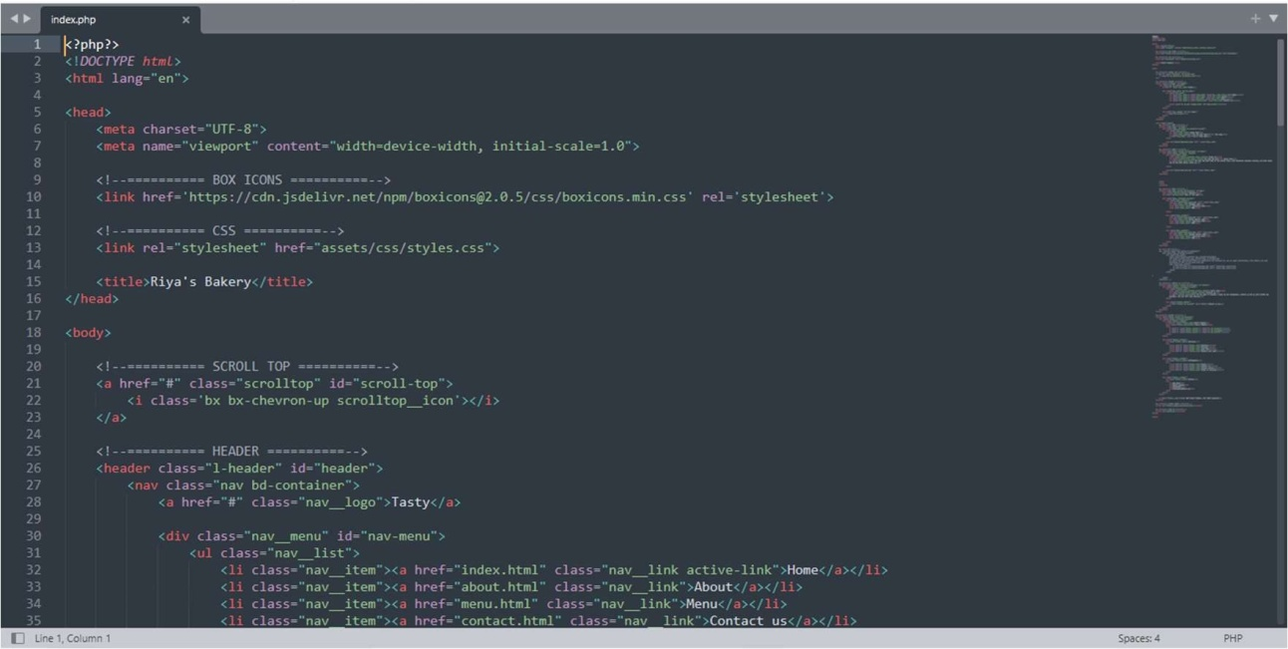

Figure 1.1.1. Sublime text

Sublime Text Editor is a full featured Text editor for editing local files or a code base. It includes various features for editing code base which helps developers to keep track of changes. Various features that are supported by Sublime are as follows −

* Syntax Highlight
* Auto Indentation
* File Type Recognition
* Sidebar with files of mentioned directory
* Macros
* Plug-in and Packages

Sublime Text editor is used as an Integrated Development Editor (IDE) like Visual Studio code and NetBeans. The current version of Sublime Text editor is 3.0 and is compatible with various operating systems like Windows, Linux and MacOS.

The Hypertext Markup Language, or HTML is the standard markup language for documents designed to be displayed in a web browser. It can be assisted by technologies such as Cascading Style Sheets (CSS) and scripting languages such as JavaScript.

Web browsers receive HTML documents from a web server or from local storage and render the documents into multimedia web pages. HTML describes the structure of a web page semantically and originally included cues for the appearance of the document.

HTML elements are the building blocks of HTML pages. With HTML constructs, images and other objects such as interactive forms may be embedded into the rendered page. HTML provides a means to create structured documents by denoting structural semantics for text such as headings, paragraphs, lists, links, quotes and other items. HTML elements are delineated by *tags*, written using angle brackets. Tags such as and directly introduce content into the page. Other tags such as surround and provide information about document text and may include other tags as sub-elements. Browsers do not display the HTML tags, but use them to interpret the content of the page.

<**input** />

<**imp** />

<**p**>

HTML can embed programs written in a scripting language such as JavaScript, which affects the behaviour and content of web pages. Inclusion of CSS defines the look and layout of content. The World Wide Web Consortium (W3C), former maintainer of the HTML and current maintainer of the CSS standards, has encouraged the use of CSS over explicit presentational HTML since 1997.

Cascading Style Sheets (CSS) is a style sheet language used for describing the presentation of a document written in a markup language such as HTML.[1] CSS is a cornerstone technology of the World Wide Web, alongside HTML and JavaScript.[2]

CSS is designed to enable the separation of presentation and content, including layout, colours, and fonts.[3] This separation can improve content accessibility, provide more flexibility and control in the specification of presentation characteristics, enable multiple web pages to share formatting by specifying the relevant CSS in a separate .CSS file which reduces complexity and repetition in the structural content as well as enabling the .CSS file to be cached to improve the page load speed between the pages that share the file and its formatting.

Separation of formatting and content also makes it feasible to present the same markup page in different styles for different rendering methods, such as on-screen, in print, by voice (via speech-based browser or screen reader), and on Braille-based tactile devices. CSS also has rules for alternate formatting if the content is accessed on a mobile device.

The name *cascading* comes from the specified priority scheme to determine which style rule applies if more than one rule matches a particular element. This cascading priority scheme is predictable.

The CSS specifications are maintained by the World Wide Web Consortium (W3C).

Internet media type (MIME type) is registered for use with CSS by RFC 2318

text/CSS

(March 1998). The W3C operates a free CSS validation service for CSS documents.

JavaScript is a cross-platform, object-oriented scripting language used to make webpages interactive (e.g., having complex animations, clickable buttons, popup menus, etc.). There are also more advanced server-side versions of JavaScript such as Node.js, which allow you to add more functionality to a website than downloading files (such as Realtime collaboration between multiple computers). Inside a host environment (for example, a web browser), JavaScript can be connected to the objects of its environment to provide programmatic control over them.

JavaScript contains a standard library of objects, such as Array, Date, and Math, and a core set of language elements such as operators, control structures, and statements. Core JavaScript can be extended for a variety of purposes by supplementing it with additional objects; for example:

* *Client-side JavaScript* extends the core language by supplying objects to control a browser and its *Document Object Model* (DOM). For example, client-side extensions allow an application to place elements on an HTML form and respond to user events such as mouse clicks, form input, and page navigation.
* *Server-side JavaScript* extends the core language by supplying objects relevant to running JavaScript on a server. For example, server-side extensions allow an application to communicate with a database, provide continuity of information from one invocation to another of the application, or perform file manipulations on a server.

This means that in the browser, JavaScript can change the way the webpage (DOM) looks. And, likewise, Node.js JavaScript on the server can respond to custom requests from code written in the browser.

Analysis is the detailed study of the various operations performed by a system and their relationships within and outside of the system. Depending upon the feasibility study we can analysis the problem of our exiting and trying to implement the advanced working in our new proposed system.

## PRODUCT DESCRIPTION: -

An online Bakery shop that allows users to check for various bakery products available at the online store and purchase online. The project consists of list of bakery products displayed in various categories. The user may browse through these items as per categories. If the user likes a product, he may add it to his shopping cart. Once user wishes to checkout, he must register on the site first. He can then login using same id password next time. Now he may pay through a credit card or cash on delivery.

## SYSTEM OBJECTIVES: -

* To provide good quality products.
* To be competitive in the market.
* Languages = HTML, CSS.

## SOFTWARE TOOL USED: -

The whole project is made by HTML, CSS, JavaScript and PHP language.

# FEASIBILITY STUDY

Depending on the problem defined the project is expanded to a more detailed feasibility study. A feasibility study is a test of the system proposal according to its work ability to meet user need and effective use of resources.

*Different Feasibility Study:*

## Technical Feasibility:

It centers the existing computer system i.e.

Hardware & Software etc. and determines whether these technical resources are sufficient for proposed system.

## Economic Feasibility:

Economic Feasibility is the most important study

determines the cost and benefits of the proposed system and compares with the budget. The cost of the project includes the cost of hardware, software development implementation.

## Operational Feasibility:

In the operational feasibility determine that the system will operate in the way that user wants. Our system is working in the way of the user wants, so our system is operational feasible.

# SYSTEM DESIGN: -

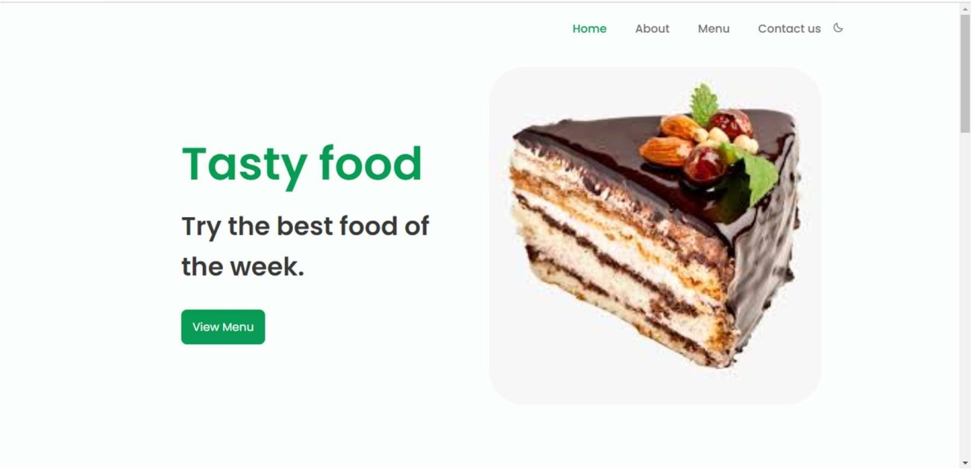

Figure 4.1. Home page of Bakery Management

At first, we are introduced to the home page of our website. Here we can see four different buttons/tabs at the top right corner with a moon symbol.

The Front page also consists a ‘View Menu’ button at the center.

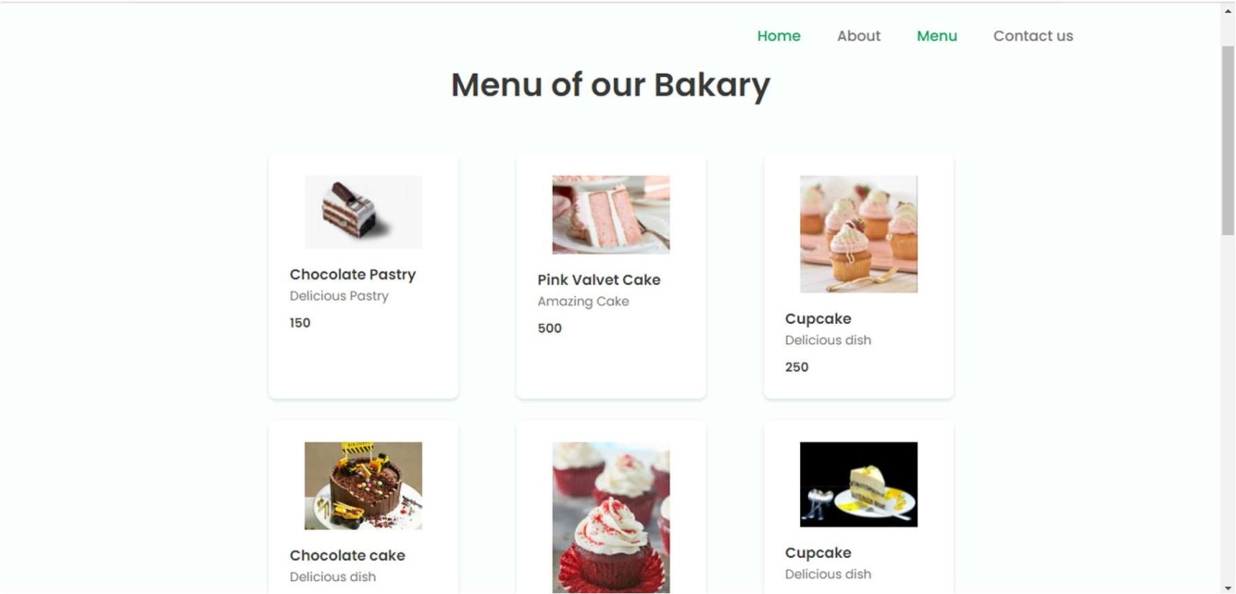When we click on view menu button, we’ll come to menu page of our website.

Figure 4.2. Menu page of Bakery Management

It consists a list of bakery products displayed in various categories. We can select our favorite item and then order that. There are so many items like cake, pastries, chocolates etc. with their price.

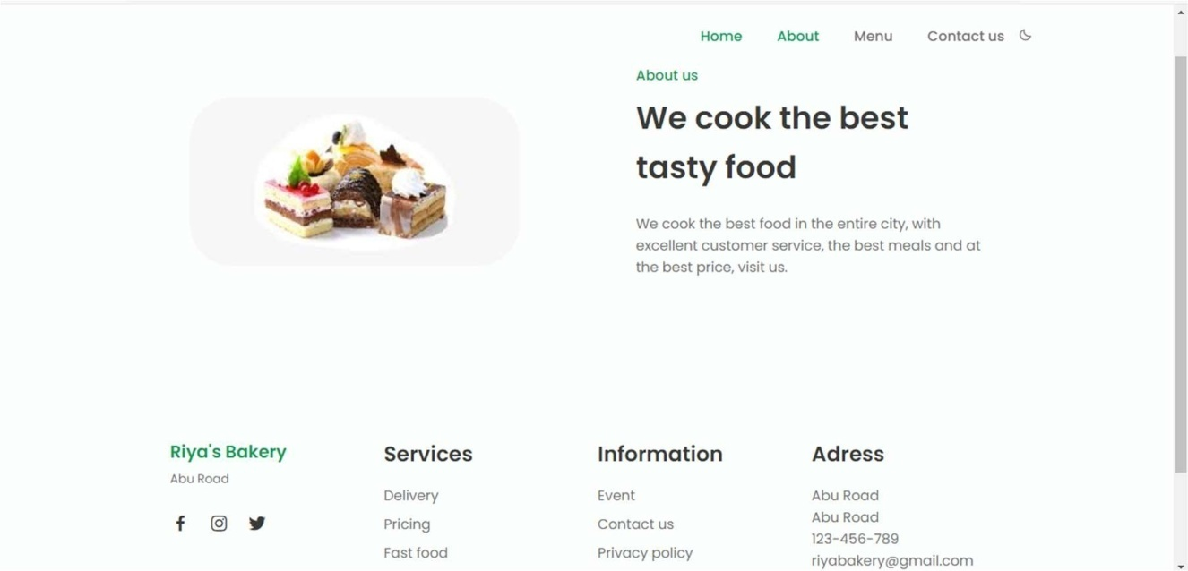

Figure 4.3. About us page

As you click on the ‘About’ tab you will reach to the about page where you will see some information about our website and our restaurant.

When we click on contact us tab, we come to the contact us page of our website.

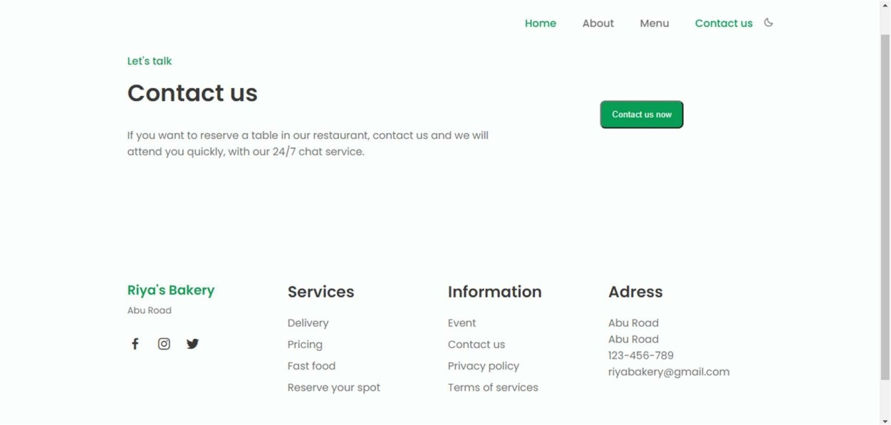

Figure 4.4. Contact us page

There is 24/7 chat service is available on our website. So, if a customer wants to reserve a table, then he/she can reserve it by this contact us tab.

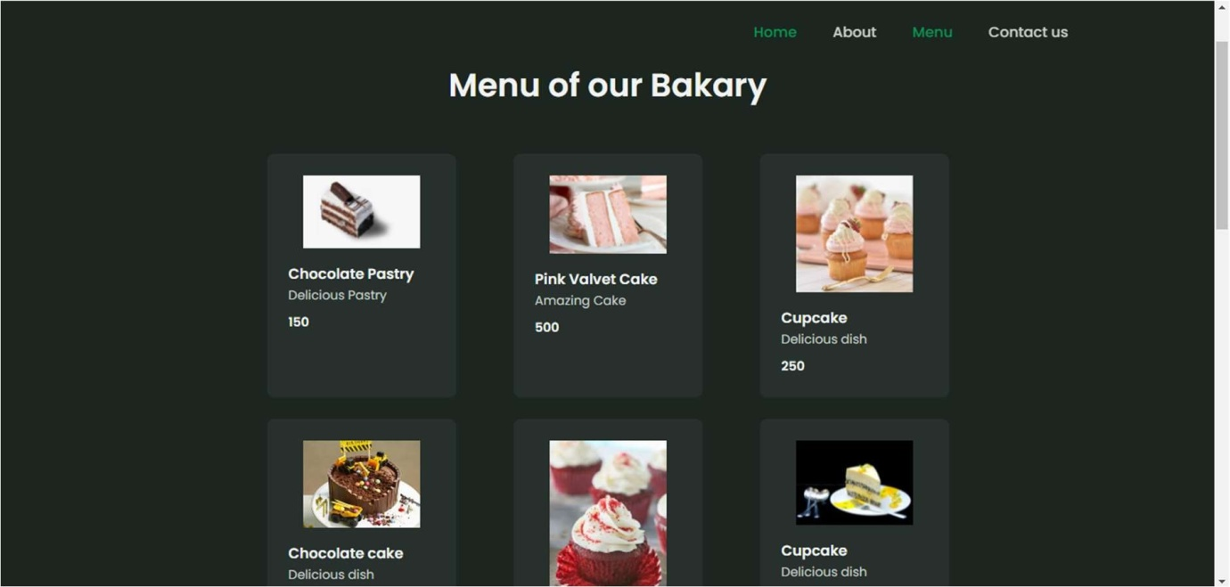

Figure 4.5. Home page with Dark mode

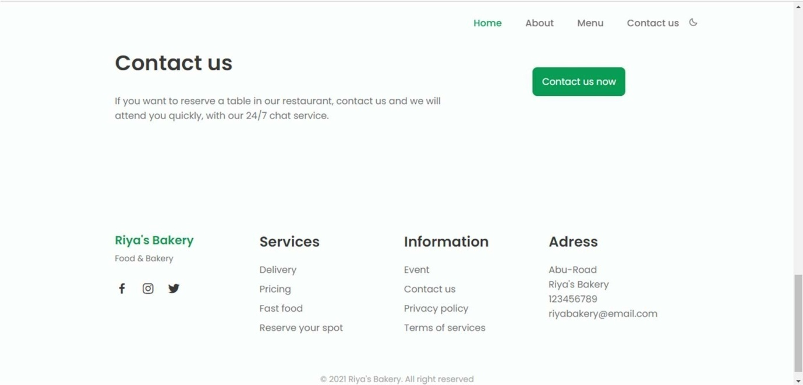 After clicking the moon symbol, all the pages of our website change their color to dark.

Figure 4.6. services and address

At the down side of every page, we can see services, information and address of our bakery. Here, we can see services like delivery, pricing, fast food and reserve your spot so, you can check our delivery status and reserve or book a table in our restaurant.

Also, you can see some information like events, contact, privacy policy and terms of services.

And at the down right corner, you can see address of our bakery/restaurant.

If you want to connect with us then, at the down left corner, there are links of our twitter, Facebook and Instagram account.

# 5. DATABASE

# Database design –

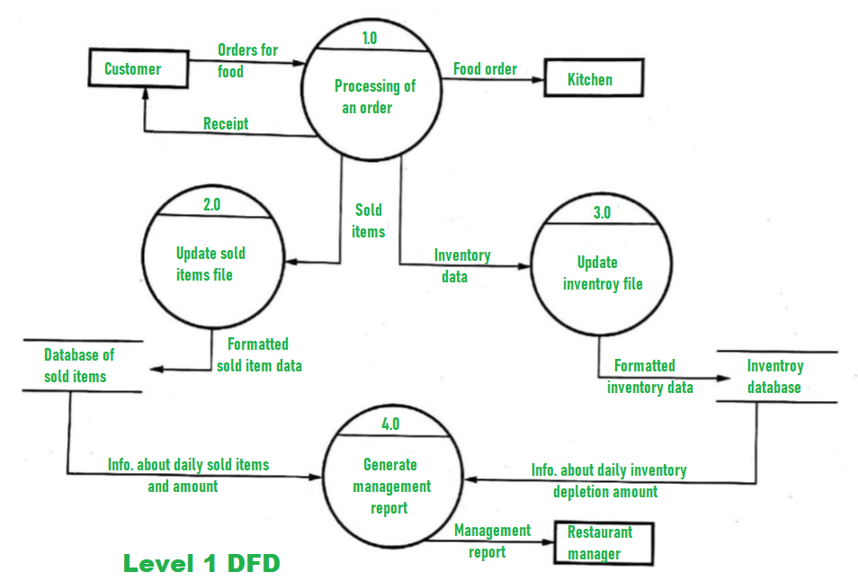

Figure 6.1. ER Diagram

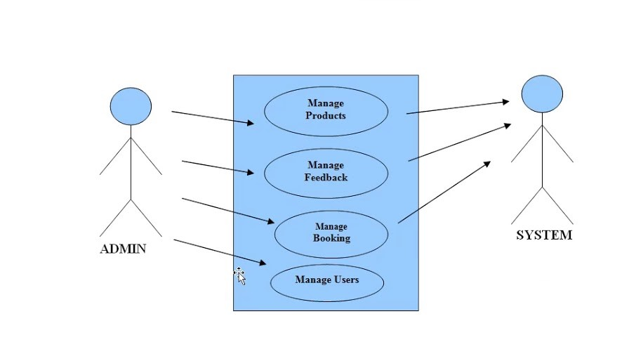

# Database Name:- contact

# No. of Tables:- 1

# 

# Figure 6.2. List Of Tables

# Table name: - contact_us:-

# 

# Figure 6.4. Table-contact

# FUTURE SCOPE

A bakery management plan can be used to garner interest from potential investors or loans from a bank. Additionally, it is helpful to you as an owner. Creating a Bakery management plan allows you to thoroughly analysis every detail of your potential business. This includes things as small as the equipment you will need or as big as the space for your business. While your bakery may have started as a vision, evolving it into a solid plan will allow you to prove to yourself and others that it is a viable business venture.

* The system generates types of information that can be used for various purposes.
* Be easy to understand by the user and operator.
* It satisfies the user interface
* Be easy to operate

To conclude the description about the project: The project developed using Sublime text is based on the requirement specification of her user and the analysis of the existing system, with flexibility for future enhancement.

The expanded functionality of today’s website requires an appropriate approach towards website development. This Bakery management website is designed for people who want to order their food online. So, people can easily see what he/she want to buy in our menu and then he/she can order online. The delivery process of ours is also very good and fast so we can perfectly deliver items like cake, pasteries and fast food. Even people can reserve their tables on our restaurent using our website, so they can save their time.

Identification of the drawbacks of the existing system leads to the designing of computerized system that will be compatible to the existing system with the system which is more user-friendly and more GUI oriented.

## Books:

**Online references:**

* + 1. YouTube
    2. Sublime Text
    3. W3School
    4. Tutorial point